**Three Types of Minds, Which Is Yours?**

To speak of the mind is to speak of a somewhat abstract concept, which is not at all clear for many people. It is a word that aims to encompass the processes that happens in our brain: thought, consciousness, perception, beliefs, desires, sensations, etc. **The mind is the terrain where conscious, unconscious and functional processes take [place](https://exploringyourmind.com/i-will-love-you-in-silence-a-place-where-words-are-unnecessary/).**

That mind is reflected in ideas, actions and different manifestations of brain activity. All this is produced from structured processes. In other words, **all this mental [activity](https://exploringyourmind.com/never-seen-images-fetal-brain-activity/) is not random, rather it obeys patterns or blueprints that are learned throughout life.** This does not mean that it is something unchangeable. In the brain, everything is susceptible to change.

According to how these processes occur, **some scholars have proposed the existence of three [types](https://exploringyourmind.com/3-types-emotional-dependence/) of minds: the rigid, the fluid, and the flexible.** Each of them has its own characteristics and obeys a different kind of logic. Let’s look at each of them.

**Rigid minds: resistance to adopting new perspectives**

Education is the factor that most influences the configuration of our minds. It is normal for people with rigid minds to also be children of rigid parents. That rigidity is, in principle, a defense mechanism. **Fixed ideas give you a feeling of greater control and protect you from uncertainty.** Those who have these traits are ideal for disciplined jobs and activities.



On the other hand, **those who have rigid minds could also be somewhat superficial. They do not stop to analyze or evaluate the validity of ideas or actions.** They assume that everything must happen in an orderly fashion, which is also predetermined.

**This leads to their having great difficulties to be creative and that is why they usually limit themselves to repeating themselves.** They may feel very confused and helpless if something or someone takes them out of their comfort zone. The lack of control over situations usually generates a lot of anguish and they suffer for it.

**Fluid minds: a [chameleon](https://en.wikipedia.org/wiki/Chameleon" \t "_blank)-like perspective**

**The opposite of rigid minds is true for fluid minds. They are unable to be consistent and that’s why they adapt to whatever goes on around them.** They take the shape of the container where they are housed. They are characteristic of people who have given up any kind of control over their circumstances.

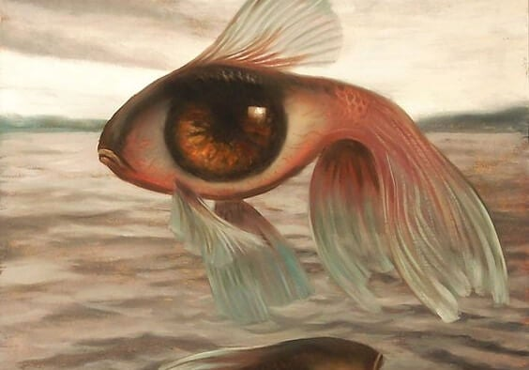

**This type of mind is representative of people who have needs or need someone to direct them.** They have a hard time making decisions and, even more, taking positions on things. They do not know what to think. And since they do not know, they delegate that task to others who they feel has the certainty they that they lack.

Those who have these kinds of minds also have a hard time being determined. **They don’t really set goals, rather they let others impose goals on them, which is enough for them.** They can be very good at tasks that require a lot of subordination. In one way or another, they complement rigid minds.

**Flexible minds: a point of balance**

Flexible minds are characterized by being adaptable. Being adaptable does not mean that, like fluid minds, they passively accept whatever happens. Its adaptation is thought through and creative. **They know how to situate themselves within reality without imposing their will, but also without submissively accepting that of others.**



In this case, **[thoughts](https://exploringyourmind.com/thoughts-destroy-also-heal/)** guide actions. Reality is an object that is processed and for which there is analysis and expansion. There is openness to discussions, which means flexible minds can change opinions and adjust ideas. It is, in some way, a humble mind. **It does not believe it owns the truth, but it does not yield to the irrational or erroneous, since it has its own criteria.**

This makes relating to the world more friendly and constructive. This type of mind also creates the conditions for it to keep developing. **Life is change, and change is positive because it challenges us and at the same time helps us to grow.**

None of us has purely one of these types of minds. **We all have a little of each of them, although the features of one or the other usually predominate.** Nor can it be said that there are “bad minds” and other “good minds”. However, it is worthwhile to understand that there are ways of thinking that help us to be happier, while others make us stagnate or dominated by others.